BLOOD BANK MANAGEMENT SYSTEM

## A PROJECT REPORT

*Submitted by*

# CH.S.K. GOWTHAM

# [Reg No: RA2211027010149]

# S.SAI CHARANI

# [Reg No: RA2211027010186]

*Under the Guidance of*

# DR. SUTHANTHIRA DEVI

Assistant Professor, Department of Data Science and Business Systems

*In partial fulfilment of the requirements for the degree of*

**BACHELOR OF TECHNOLOGY**

**in**

**COMPUTER SCIENCE AND ENGINEERING**

# with a specialization in BIG DATA ANALYTICS



**FACULTY OF ENGINEERING AND**

**TECHNOLOGY**

**SCHOOL OF COMPUTING**

**SRM UNIVERSITY OF SCIENCE AND**

**TECHNOLOGY**

**KATTANKULATHUR**

**MAY 2024**



### **SRM INSTITUTE OF SCIENCE AND TECHNOLOGY KATTANKULATHUR – 603 203**

**BONAFIDE CERTIFICATE**

Certified that this B.Tech project report titled “**BLOOD BANK MANAGEMENT SYSTEM**” is the bonafide work of Mr.C.H.S.K.Gowtham [Reg. No.: RA2211027010149] and Ms. S.SaiCharani [Reg. No.RA2211027010186] who carried out the project work under my supervision. Certified further, that to the best of my knowledge the work reported herein does not form part of any other thesis or dissertation on the basis of which a degree or award was conferred on an earlier occasion for this or any other candidate.

Dr. Suthanthira Devi

Assistant Professor

Department of Data Science and Business Systems

Dr. Lakshmi M

**HEAD OF THE DEPARTMENT**

Department of Data

Science and Business Systems

**ABSTRACT**

The "Blood Bank Management System " is a user-centric platform designed to optimize the blood donation process. The system begins with a secure recipient login, allowing users to efficiently search for specific blood types within their vicinity. By integrating real-time blood inventory tracking and location-based services, the system provides recipient with instant information on the availability of the desired blood type in nearby areas.

This Blood Bank Management System addresses the need for a streamlined, accessible, and community-driven approach to blood donation. By leveraging technology, real-time data, and user-friendly interfaces, the system aims to bridge the gap between donors and recipients, making the blood donation process more efficient, transparent, and responsive to urgent needs.

# 

# ACKNOWLEDGEMENT

We express our humble gratitude to **Dr. C. Muthamizhchelvan**, Vice-Chancellor, SRM Institute of Science and Technology, for the facilities extended for the project work and his continued support.

We extend our sincere thanks to Dean-CET, SRM Institute of Science and Technology, **Dr. T.V.Gopal**, for his invaluable support.

We wish to thank **Dr. Revathi Venkataraman**, Professor & Chairperson, School of Computing, SRM Institute of Science and Technology, for her support throughout the project work.

We are incredibly grateful to our Head of the Department, **Dr. M. Lakshmi,** Professor, Department of Data Science and Business Systems, SRM Institute of Science and Technology, for her suggestions and encouragement at all the stages of the project work.

Our inexpressible respect and thanks to our guide, **Dr.Suthanthira Devi**, Assistant Professor, Department of Data Science and Business Systems, SRM Institute of Science and Technology, for providing us with an opportunity to pursue our project under his mentorship. He provided us with the freedom and support to explore the research topics of our interest. His passion for solving problems and making a difference in the world has always been inspiring.

We sincerely thank the Data Science and Business Systems Department staff and students, SRM Institute of Science and Technology, for their help during our project. Finally, we would like to thank parents, family members, and friends for their unconditional love, constant support, and

**OBJECTIVE**

The primary objective of your Blood Bank Management System project is to facilitate a streamlined and efficient process for individuals in need of blood to connect with available blood resources. The project aims to achieve the following objectives:

* User Registration and Authentication:

Enable users to create accounts and log in securely to access the system.

* User Profile Management:

Allow users to fill and manage their personal details, including information relevant to blood donation and medical history.

* Location-Based Blood Search:

Implement a search functionality for users to find available blood resources in specific locations.

* API Integration:

Utilize external APIs to gather real-time information about blood availability in various blood banks and locations.

* User-Friendly Interface:

Design an intuitive and user-friendly interface to enhance the user experience during the registration, search, and interaction processes

**PROBLEM STATEMENT**

The existing blood donation systems face notable challenges in efficiently connecting donors with recipients, resulting in delays and a lack of real-time information. Current methods for locating specific blood types often rely on manual and time-consuming processes, leading to a disjointed and less responsive blood donation ecosystem

.

The absence of a centralized platform for recipients to easily search for and access real-time information on blood availability in nearby areas exacerbates these challenges. Addressing these issues requires the development of a comprehensive Blood Bank Management System that provides a user-friendly interface for receipents to seamlessly locate, inquire about, and find specific blood types based on immediate needs.

**SOFTWARE REQUIREMENTS**

* **Front End:**

HTML and CSS create the visual structure and styling for user interaction.

* **Back End:**

SQL Database (e.g., MySQL, PostgreSQL) manages data storage, ensuring reliability and efficiency.

* **Connection:**

Python, integrated with frameworks like Django or Flask, orchestrates the interaction between the user interface and the database, handling logic and data flow for a seamless and dynamic user experience.

**ARCHITECTURE DIAGRAM**

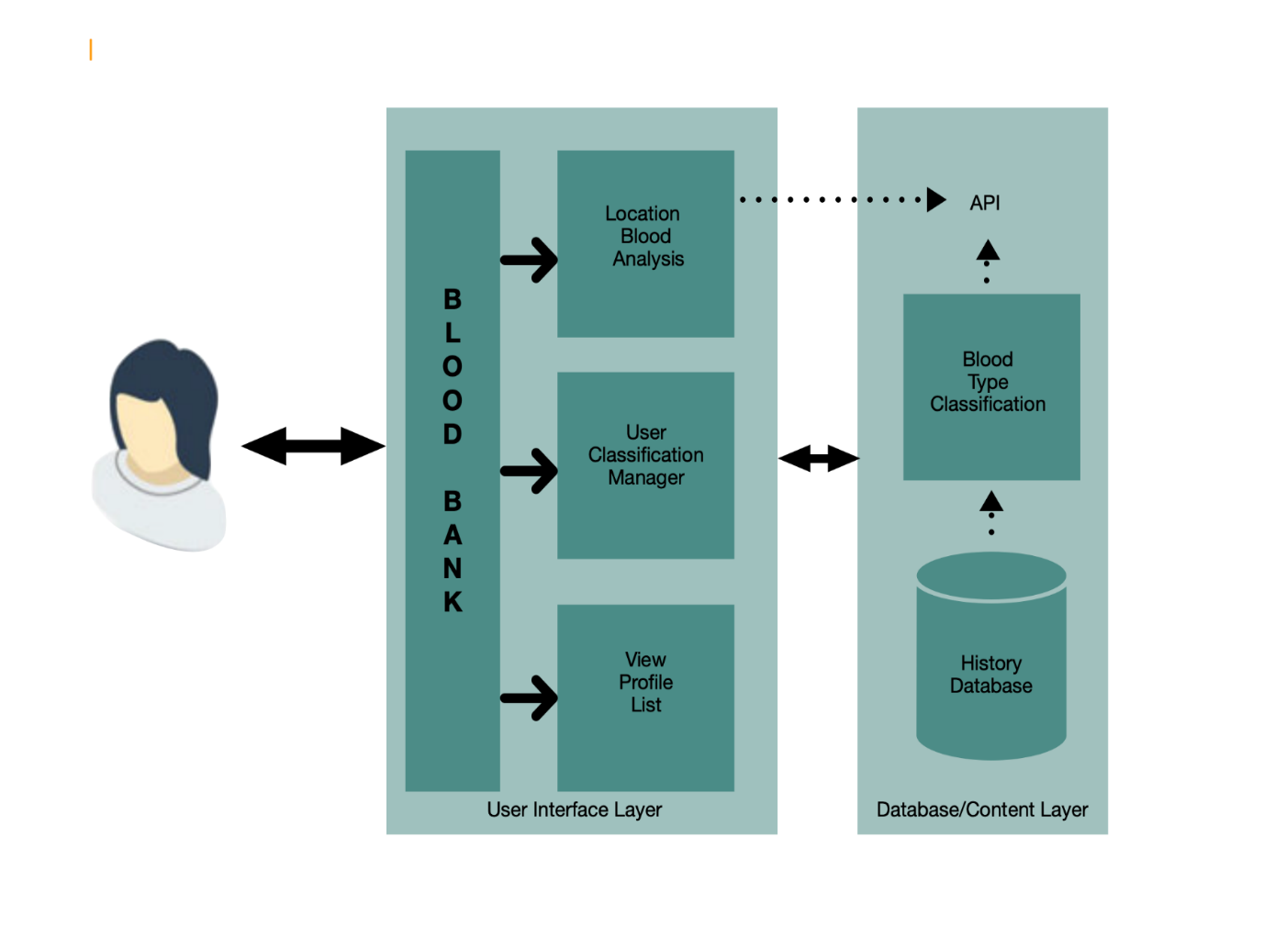

**ER DIAGRAM**

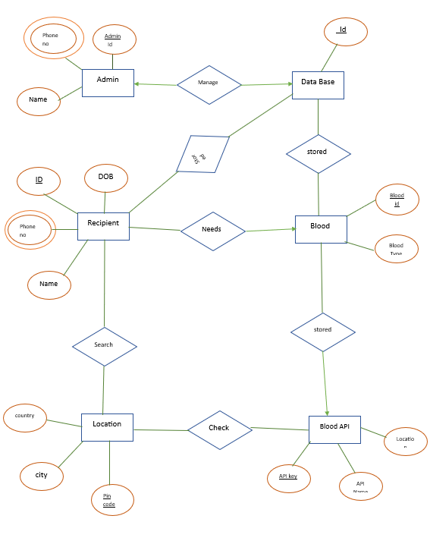

**Identification of Entity and Relationships**

Entities:

* Blood Bank
* Admin
* Recipient
* Blood
* Location
* Blood API

Relationships:

* Admin manages blood bank
* Admin stores data in database
* Blood bank stores blood
* Recipient needs blood from blood bank
* Blood Bank checks blood with Blood API
* Blood API uses location API